Design, Implementation and Evaluation of a
Thread-Safe Banking System

Introduction

This report evaluates the design and implementation of a thread-safe banking system in Python. Several users can deposit, withdraw, read balances and transfer funds while sharing account state. I argue that correctness depends on protecting the rules governing that state, because a method that works in isolation can still fail when its read and update steps overlap with another thread. This report examines how object-oriented design, locking, deadlock prevention and targeted testing were used to control that risk, addressing the module outcomes of advanced object-oriented design and secure coding through validation, controlled state access and testing.

Method Selection and System Design
I used iterative object-oriented decomposition followed by concurrency risk analysis. The assignment was separated into three responsibilities: protecting account state, generating concurrent activity and validating behaviour. I then worked from the invariants that must survive concurrency. Deposits must not lose updates, withdrawals must not spend the same balance twice, failed transfers must leave both accounts unchanged, and opposite transfers must continue without circular waiting. Diagrams helped check whether responsibility and control flow matched those risks before testing.

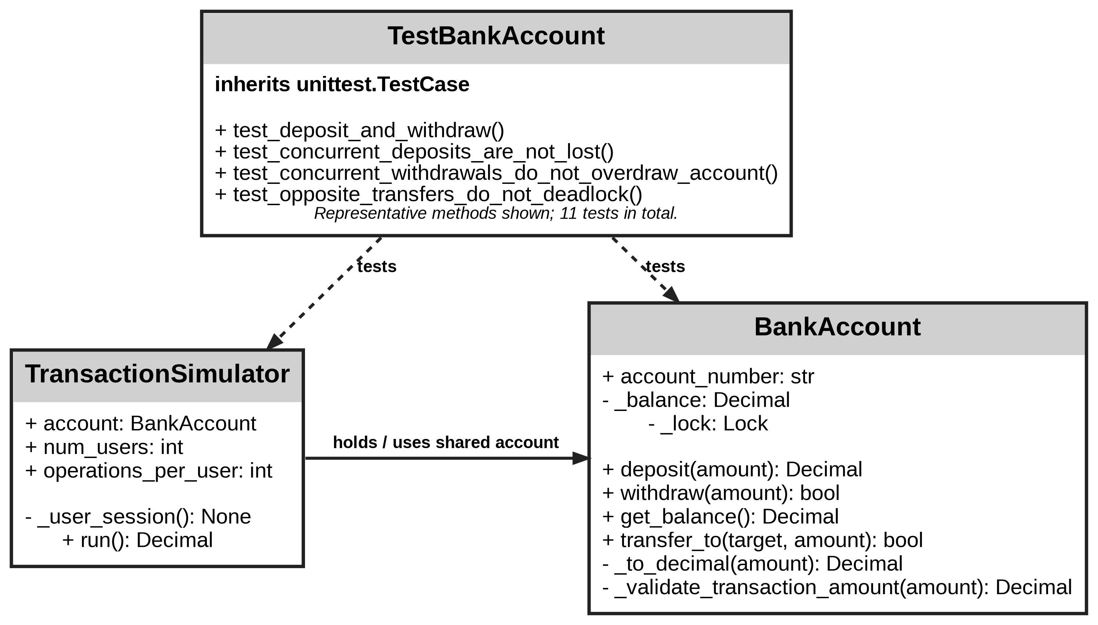

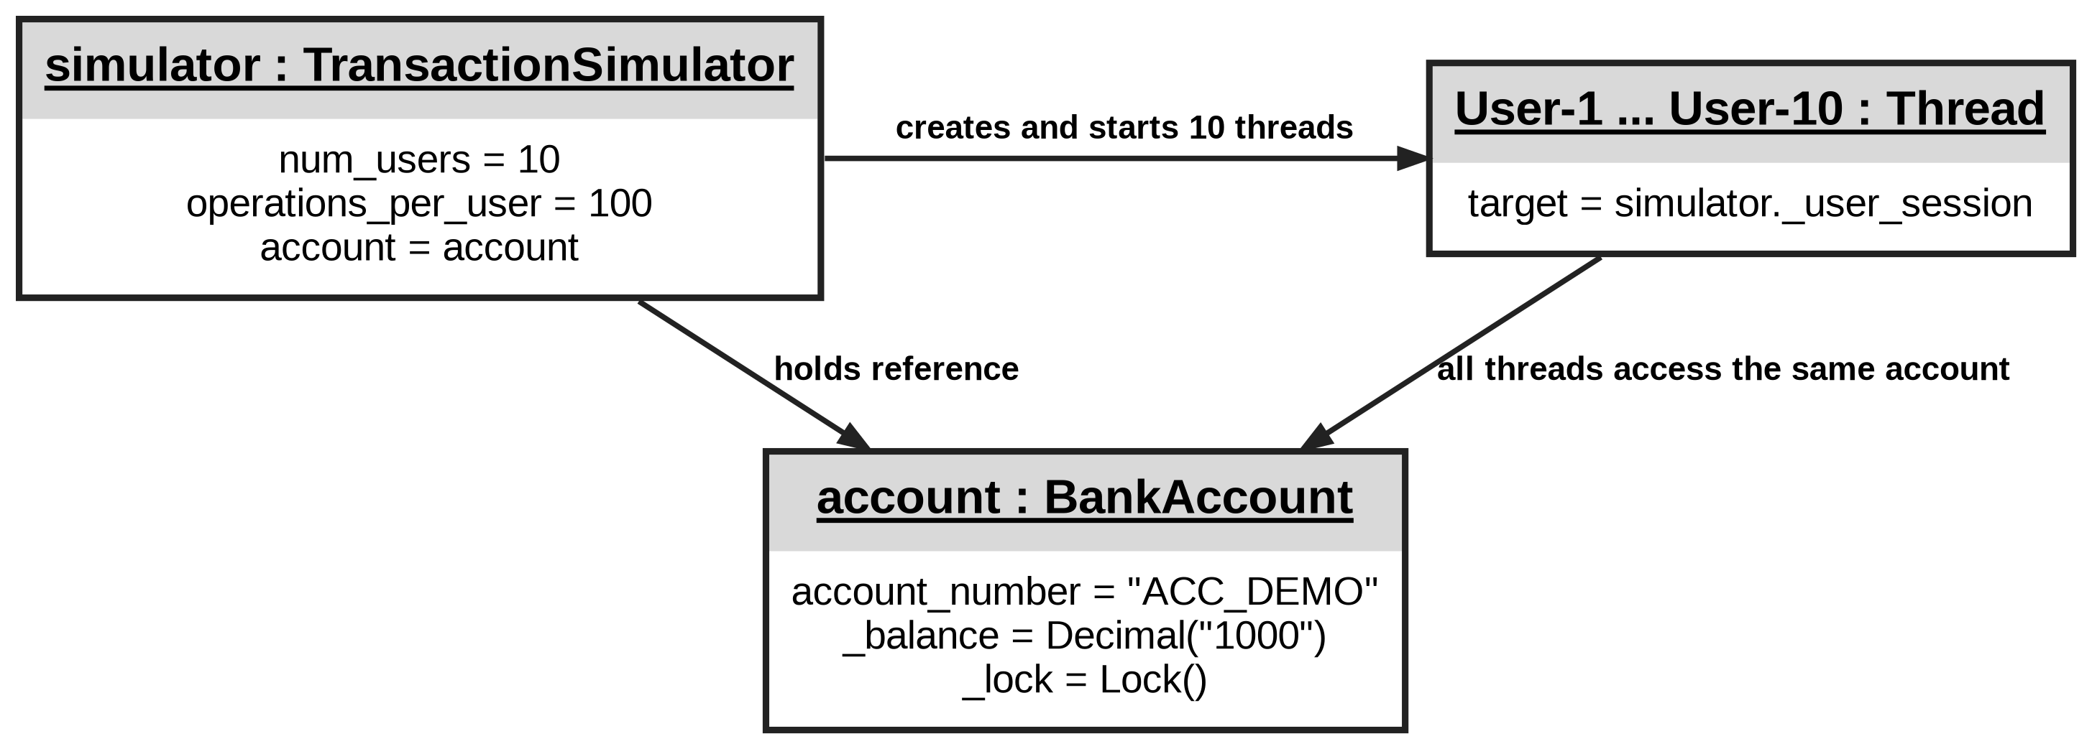

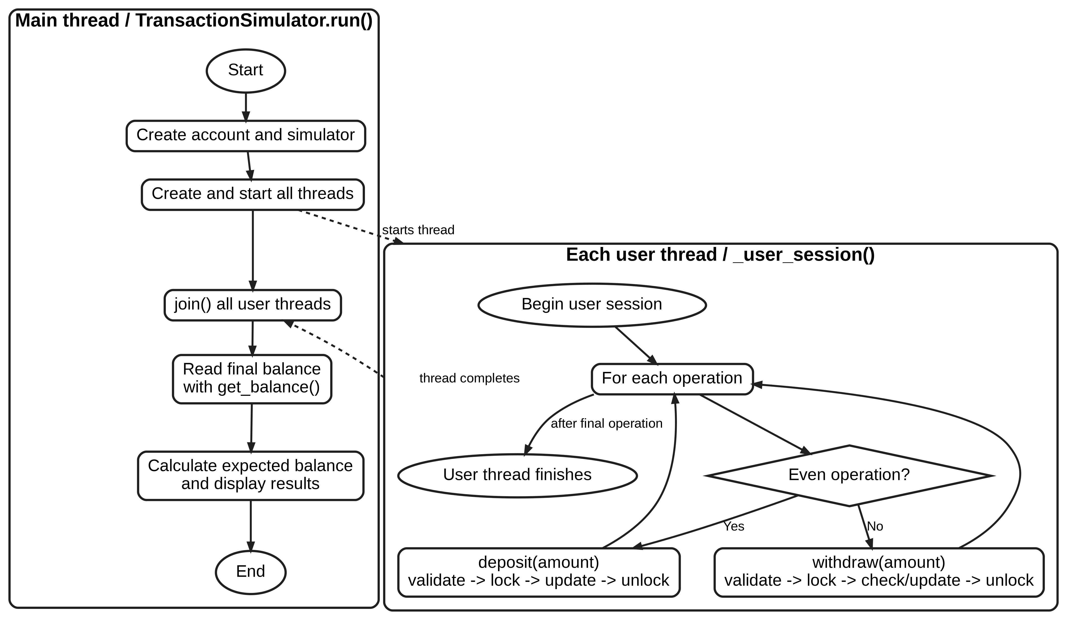

Figures 1 and 2 show that TransactionSimulator reuses one BankAccount instance while the account retains control of its balance. Giordano et al. (2024) found that inheritance and delegation were associated with defect-proneness and maintenance effort, although the effects varied across projects and mechanisms. In this design, shallow composition is preferable because simulated users share one protected BankAccount, while inheritance would add complexity without addressing concurrency. Figure 3 separates the main thread, which starts and joins workers, from the per-user flow where deposits and withdrawals access locked account state.

However, the design also reflects a Monitor Object-style approach to concurrency. A monitor keeps shared state and access control together. BankAccount follows this principle by storing _balance and threading.Lock in the same object and routing balance access through locked methods (Schmidt et al., 2000). I use the term “style” because this is a compact Python form, not a full monitor with condition variables. Flageol et al. (2023) show that the value of design patterns depends on how they are implemented and evaluated. I take that as a reason to judge the pattern by its practical contribution, which in this case is keeping synchronisation close to the state it protects.

Looking at the design through SOLID, Single Responsibility is strongest across BankAccount, TransactionSimulator and the test class, since each handles a distinct part of the system. Open/Closed is less complete because changing the fixed transaction pattern still requires editing _user_session(). Liskov Substitution is not exercised here because no subclasses are used. Constructor injection supports reuse and testing, although TransactionSimulator still depends on the concrete BankAccount class

Thread Safety, Locking and Secure Coding
Each BankAccount owns a threading.Lock, and deposit(), withdraw() and get_balance() acquire it before accessing _balance. A mutex lock fits the requirement because only one thread should enter a balance-critical section at a time. A binary semaphore could provide similar exclusion, but it would add no useful behaviour here; a semaphore configured with multiple permits would allow more than one thread into the critical section and would not protect the balance invariant required by this design. RLock adds re-entrancy that the current call structure does not need. Per-account locking also allows unrelated accounts to proceed independently, although a heavily used single account can still become a contention point.
The withdrawal path shows why lock placement matters. The funds check and deduction must remain in the same critical section. If the check sat outside the lock, two threads could both see enough money and both proceed. Keeping both steps inside the with block protects the account rule that a withdrawal cannot exceed the available balance. For this program, that business invariant matters more than simply being able to say that a lock was used.

Code snippet 1. Withdrawal check and update inside one critical section.
value = self._validate_transaction_amount(amount)
with self._lock:
if value > self._balance:
return False
self._balance -= value
return True

Transfers need two locks, which creates a deadlock risk. If one thread holds A and waits for B while another holds B and waits for A, neither can progress. transfer_to() sorts both accounts before acquiring either lock, using account_number as the normal ordering key and id(account) as a tie-breaker. Opposite transfers then derive the same order even when source and destination are reversed. Both balances are changed while both locks remain held, which also means other operations using the public locked interface cannot observe a successful transfer halfway through.

Code snippet 2. Consistent two-account lock ordering and atomic transfer.
first, second = sorted(
(self, target),
key=lambda account: (account.account_number, id(account)),
)
with first._lock:
with second._lock:
if value > self._balance:
return False
self._balance -= value
target._balance += value

The ordering rule still has a weakness. account_number is intended to be unique, but the class does not enforce uniqueness and the attribute remains writable. A stronger version should make account identity immutable and validate uniqueness centrally, turning an assumption into an enforced rule.
Charoenwet et al. (2024) found that code reviewers identified many security-related coding weaknesses, yet some concerns were only acknowledged or remained unresolved. I take from that study that important correctness rules are safer when the object enforces them directly. Transaction values are validated before use, non-finite values and negative opening balances are rejected, and balance changes pass through locked methods. Alromaizan et al. (2026) also identify input validation as a recurring secure-coding concern. These controls are appropriate here, although currency, decimal scale, authentication, authorisation and persistence would still be required in a real banking system.

Testing, Debugging and Results
The final suite contains twelve tests covering normal behaviour, validation, transfers, concurrency and deadlock-related behaviour. All twelve passed, and the simulator returned the expected £1000 balance. The stronger evidence comes from what the concurrency tests expose.
Threads do not run in a fixed order, so a test can pass because the scheduler chose a harmless interleaving. Deligiannis et al. (2023) address this through controlled exploration of concurrent schedules. My tests are less exhaustive, but threading.Barrier brings workers to a common starting point in the deposit, withdrawal and opposite-transfer cases. This creates deliberate contention, although it cannot cover every possible schedule.

Code snippet 3. Barrier-based concurrent withdrawal test.
number_of_threads = 20
barrier = threading.Barrier(number_of_threads)
results = [False] * number_of_threads
def worker(index):
barrier.wait()
results[index] = account.withdraw(10)

An early testing limitation was that the first concurrency test focused on deposits, which could expose lost updates but did not challenge the check-and-update logic in withdraw(). I added a limited-funds case where twenty threads each request £10 from a £100 account; exactly ten should succeed. The transfer ordering was also strengthened because the brief describes account numbers as unique while the class does not enforce that rule, so id(account) was added as a consistent tie-breaker for the two live account objects.
The opposite-transfer test runs two threads in reverse directions and waits up to five seconds for both to finish. Passing it supports the chosen ordering in that scenario, but I would not present it as proof of universal deadlock freedom because later code could introduce another lock order or shared resource.

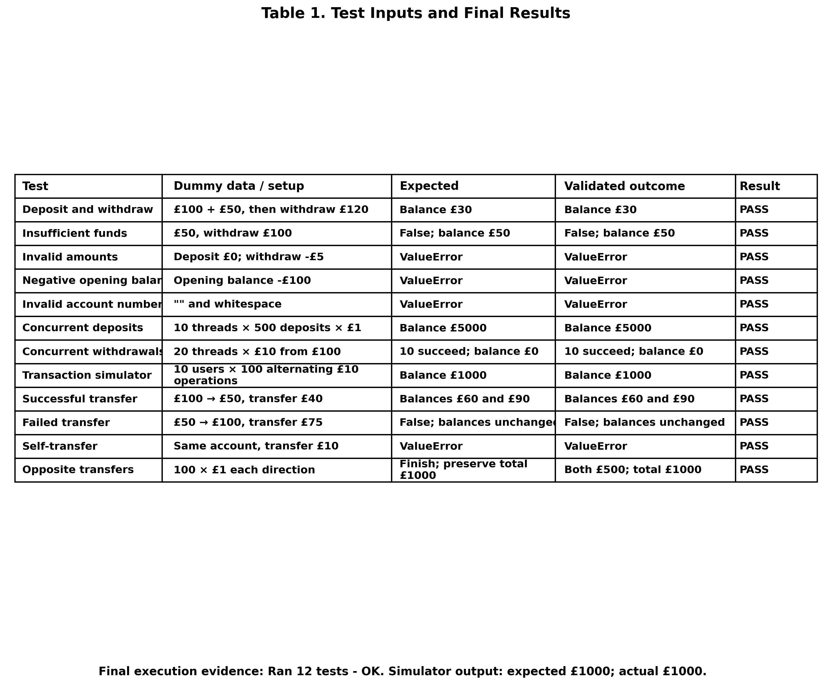

Critical Evaluation and Reflection

The implementation is maintainable at this scale, although I would not assume this would remain true after significant extension. Heričko and Šumak (2023) show that maintainability judgements vary with the measures used, while Giordano et al. (2024) found that inheritance and delegation had different relationships with maintenance effort across projects. I take from both studies that maintainability depends on whether responsibilities remain clear as complexity grows. BankAccount owns state and synchronisation, while TransactionSimulator generates concurrent activity. That separation works here, but the hard-coded transaction pattern, mutable account identity and transfer logic inside BankAccount would need attention in a larger system.

The testing process had the biggest effect on my understanding of concurrency. The deposit test initially seemed convincing because ten threads could perform 500 deposits each and still reach £5000. Looking at withdraw() exposed a harder problem because the balance check and update must remain together. The contested-withdrawal test made the purpose of the critical section clearer and helped me understand the lock as protection for a specific invariant.

Transfers also changed how I understood locking. A lock can prevent a race condition while still creating a liveness risk when several locks are involved. The opposite-transfer test, together with consistent lock ordering, helped me see deadlock prevention as a design concern rather than something testing can fix afterwards. Deligiannis et al. (2023) also show why finite concurrency tests need cautious interpretation. My barriers increase contention, but they cannot cover every execution order.

Conclusion

The strongest feature of the solution is the traceability between risk, design and testing. Per-account locks protect shared balances, withdrawal checks and updates remain in one critical section, and transfers use consistent lock ordering to reduce circular waiting. The eleven passing tests provide evidence that these controls work in the scenarios exercised, although I would not treat them as proof of universal thread safety.

If the system were extended, I would first make account identity immutable, move cross-account transfers into a dedicated transaction service and introduce persistent transactional storage. I would also broaden concurrency testing to explore varied thread schedules. These changes would strengthen the design without losing the clarity that currently makes its concurrency behaviour easy to reason about.

References
Alromaizan, A., Alzahrani, G., Khan, A., Alhumaid, L., Siam, M.K., Khan, M.U., Faruk, M.J.H. and Shahriar, H. (2026) ‘Toward a unified framework for secure coding: A comprehensive synthesis of best practices’, Computers, 15(4), p. 220. doi: 10.3390/computers15040220.
Charoenwet, W., Thongtanunam, P., Pham, V.-T. and Treude, C. (2024) ‘Toward effective secure code reviews: An empirical study of security-related coding weaknesses’, Empirical Software Engineering, 29, article 88. doi: 10.1007/s10664-024-10496-y.
Deligiannis, P., Senthilnathan, A., Nayyar, F., Lovett, C. and Lal, A. (2023) ‘Industrial-strength controlled concurrency testing for C# programs with Coyote’, in Sankaranarayanan, S. and Sharygina, N. (eds.) Tools and Algorithms for the Construction and Analysis of Systems. TACAS 2023. Lecture Notes in Computer Science, 13994, pp. 433–452. Cham: Springer. doi: 10.1007/978-3-031-30820-8_26.
Flageol, W., Menaud, E., Guéhéneuc, Y.-G., Badri, M. and Monnier, S. (2023) ‘A mapping study of language features improving object-oriented design patterns’, Information and Software Technology, 160, 107222. doi: 10.1016/j.infsof.2023.107222.
Giordano, G., Festa, G., Catolino, G., Palomba, F., Ferrucci, F. and Gravino, C. (2024) ‘On the adoption and effects of source code reuse on defect proneness and maintenance effort’, Empirical Software Engineering, 29, article 20. doi: 10.1007/s10664-023-10408-6.
Heričko, T. and Šumak, B. (2023) ‘Exploring Maintainability Index variants for software maintainability measurement in object-oriented systems’, Applied Sciences, 13(5), 2972. doi: 10.3390/app13052972.
Schmidt, D.C., Stal, M., Rohnert, H. and Buschmann, F. (2000) Pattern-Oriented Software Architecture, Volume 2: Patterns for Concurrent and Networked Objects. Chichester: Wiley.

